**Project Description**

Back in Brazil I worked on my family company, a tourism company from my city. My idea for the Project is to create a web page to display the services from this company. Our company is specialized in boat rides in different spots in the city.

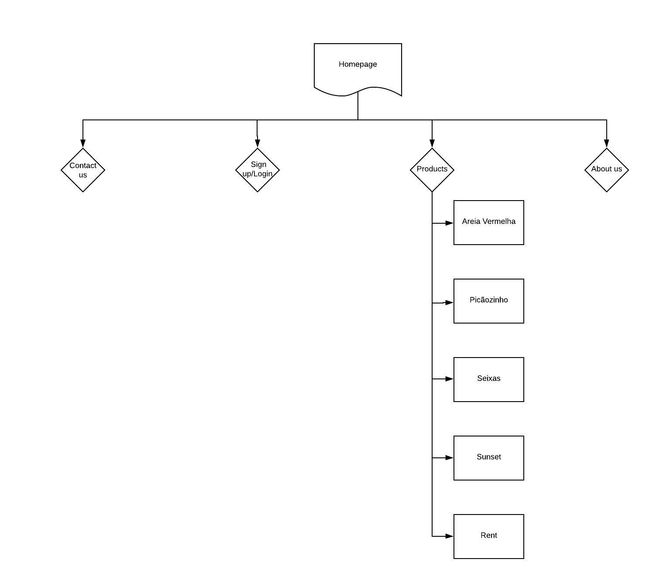

The idea is to create a homepage that has these pages:

1. Contact us
2. Sign up/Login(Form)
3. Products/Services
   1. Areia Vermelha
   2. Picãozinho natural pools
   3. natural pools of Seixas beach
   4. Sunset at jacare beach
   5. Rent
4. About us